Reference Model and IP addressing
Reference Model
A reference model is a conceptual framework that standardizes communication functions in a network. It defines how data is transmitted from one device to another through different layers.
The two most widely used reference model in networking are:
OSI model (Open System Interconnection)
The OSI (Open Systems Interconnection) Model is a set of rules that explains how different computer systems communicate over a network. OSI Model was developed by the International Organization for Standardization (ISO). The OSI Model consists of 7 layers and each layer has specific functions and responsibilities. This layered approach makes it easier for different devices and technologies to work together. OSI Model provides a clear structure for data transmission and managing network issues. The OSI Model is widely used as a reference to understand how network systems function.
Layers of the OSI
- Physical Layer
The lowest layer of the OSI reference model is the Physical Layer. It is responsible for the actual physical connection between the devices. The physical layer contains information in the form of bits. When receiving data, this layer will get the signal received and convert it into 0s and 1s and send them to the Data Link layer, which will put the frame back together. Common physical layer devices are Hub, Repeater, Modem, and Cables.
Functions of the Physical Layer
Bit Synchronization: The physical layer provides the synchronization of the bits by providing a clock. This clock controls both sender and receiver thus providing synchronization at the bit level.
Bit Rate Control: The Physical layer also defines the transmission rate i.e. the number of bits sent per second.
Physical Topologies: Physical layer specifies how the different, devices/nodes are arranged in a network i.e. bus topology, star topology, or mesh topology.
Transmission Mode: Physical layer also defines how the data flows between the two connected devices. The various transmission modes possible are Simplex, half-duplex and full duplex.

- Data Link Layer
The data link layer is responsible for the node-to-node delivery of the message. The main function of this layer is to make sure data transfer is error-free from one node to another, over the physical layer. When a packet arrives in a network, it is the responsibility of the DLL to transmit it to the Host using its MAC address. Packet in the Data Link layer is referred to as Frame. Switches and Bridges are common Data Link Layer devices.
Functions:
Framing: Framing is a function of the data link layer. It provides a way for a sender to transmit a set of bits that are meaningful to the receiver. This can be accomplished by attaching special bit patterns to the beginning and end of the frame.
Physical Addressing: After creating frames, the Data link layer adds physical addresses (MAC addresses) of the sender and/or receiver in the header of each frame.
Error Control: The data link layer provides the mechanism of error control in which it detects and retransmits damaged or lost frames.
Flow Control: The data rate must be constant on both sides else the data may get corrupted thus, flow control coordinates the amount of data that can be sent before receiving an acknowledgment.
Access Control: When a single communication channel is shared by multiple devices, the MAC sub-layer of the data link layer helps to determine which device has control over the channel at a given time.
- Network Layer
The Network Layer works for the transmission of data from one host to the other located in different networks. It also takes care of packet routing i.e. selection of the shortest path to transmit the packet, from the number of routes available.
The sender and receiver's IP address are placed in the header by the network layer. Segment in the Network layer is referred to as Packet.
Network layer is implemented by networking devices such as routers and switches.
Functions of the Network Layer
Routing: The network layer protocols determine which route is suitable from source to destination. This function of the network layer is known as routing.
Logical Addressing: To identify each device inter-network uniquely, the network layer defines an addressing scheme. The sender and receiver’s IP addresses are placed in the header by the network layer. Such an address distinguishes each device uniquely and universally.
- Transport Layer
The Transport Layer provides services to the application layer and takes services from the network layer. The data in the transport layer is referred to as Segments. It is responsible for the end-to-end delivery of the complete message. The transport layer also provides the acknowledgment of the successful data transmission and re-transmits the data if an error is found.It also adds Source and Destination port number in its header and forwards the segmented data to the Network Layer.
Example: when a web application requests a web server, it typically uses port number 80, because this is the default port assigned to web applications. Many applications have default ports assigned.
At the Receiver’s side, Transport Layer reads the port number from its header and forwards the Data which it has received to the respective application. It also performs sequencing and reassembling of the segmented data.
Functions:
Segmentation and Reassembly: This layer accepts the message from the (session) layer and breaks the message into smaller units. Each of the segments produced has a header associated with it. The transport layer at the destination station reassembles the message.
Service Point Addressing: To deliver the message to the correct process, the transport layer header includes a type of address called service point address or port address. Thus, by specifying this address, the transport layer makes sure that the message is delivered to the correct process.
- Session Layer
Session Layer in the OSI Model is responsible for the establishment of connections, management of connections, terminations of sessions between two devices. It also provides authentication and security.
Functions of the Session Layer
Session Establishment, Maintenance, and Termination: The layer allows the two processes to establish, use, and terminate a connection.
Synchronization: This layer allows a process to add checkpoints that are considered synchronization points in the data. These synchronization points help to identify the error so that the data is re-synchronized properly, and ends of the messages are not cut prematurely, and data loss is avoided.
Dialog Controller: The session layer allows two systems to start communication with each other in half-duplex or full duplex.
- Presentation Layer
The Presentation Layer is also called the Translation layer. The data from the application layer is extracted here and manipulated as per the required format to transmit over the network.
Functions of the Presentation Layer
Translation: For example, ASCII to EBCDIC.
Encryption/ Decryption: Data encryption translates the data into another form or code. The encrypted data is known as the ciphertext, and the decrypted data is known as plain text. A key value is used for encrypting as well as decrypting data.
Compression: Reduces the number of bits that need to be transmitted on the network.
- Application Layer
At the very top of the OSI Reference Model stack of layers, we find the Application Layer which is implemented by the network applications. These applications produce the data to be transferred over the network.
This layer also serves as a window for the application services to access the network and for displaying the received information to the user.
Protocols used in the Application layer are SMTP, FTP, DNS, etc.
Functions of the Application Layer
The main functions of the application layer are given below.
Network Virtual Terminal (NVT): It allows a user to log on to a remote host.
File Transfer Access and Management (FTAM): This application allows a user to access files in a remote host, retrieve files in a remote host, and manage or control files from a remote computer.
Mail Services: Provide email service.
TCP/IP Model
Layers:
Introduction to Protocols
A network protocol is a set of rules and conventions that define how data is transmitted, received, and processed across a network. These protocols enable communication between devices, ensuring data integrity, security, and efficient transfer.
Features:
- Standarized Communication:
Network protocols establish a set of rules that allow different devices and systems to communicate seamlessly. They ensure that devices from different manufacturers can work together without compatibility issues. TCP/IP enables communication between computers, routers, and mobile devices over the internet.

- Error Handling and Detection
Ensures that data is transmitted without corruption. Uses techniques like Cyclic Redundancy Check (CRC), checksums, and acknowledgment mechanisms to detect and correct errors. Example: TCP (Transmission Control Protocol) detects lost or corrupted packets and retransmits them.
- Data Compression
Reduces the size of transmitted data to improve bandwidth efficiency. Compression techniques like Huffman coding and Lempel-Ziv-Welch (LZW) minimize network congestion. Example: JPEG compression in image transmission and MP3 compression in audio streaming reduce data size while maintaining quality.
- Security and Encryption
Protects data from unauthorized access, interception, and modification. Uses encryption techniques such as SSL/TLS (Secure Socket Layer / Transport Layer Security) and IPSec to secure communication. Example: HTTPS encrypts web traffic to protect user data from hackers.
- Addressing and Routing
Addressing assigns unique identifiers to devices, while routing determines the best path for data transmission. Uses IP addresses, MAC addresses, and subnet masks to identify devices.
- Multiplexing and Demultiplexing
Multiplexing allows multiple data streams to share a single communication channel. Demultiplexing ensures that the received data is delivered to the correct application. Example: TCP and UDP port numbers help direct incoming network traffic to the appropriate service (e.g., HTTP on port 80, FTP on port 21).
Needs of Network Protocols
- Interoperability – Allows devices from different manufacturers to communicate.
- Data Integrity – Ensures that transmitted data remains unchanged.
- Security – Protects data from unauthorized access and attacks.
- Efficiency – Optimizes network performance and reduces delays.
- Scalability – Supports the expansion of networks without significant changes.
Point-to-point Protocol
Point-to-Point Protocol (PPP) is a data link layer protocol (Layer 2 of the OSI model) used to establish a direct connection between two network nodes. It is commonly used for dial-up connections, leased lines, and VPNs to transmit data over serial links.

Ip Addressing
IPV4
- Classful Addressing
Internet Protocol hierarchy contains several classes of IP Addresses to be used efficiently in various situations as per the requirement of hosts per network. Broadly, the IPv4 Addressing system is divided into five classes of IP Addresses. All the five classes are identified by the first octet of IP Address.
The first octet referred here is the left most of all. The octets numbered as follows depicting dotted decimal notation of IP Address –
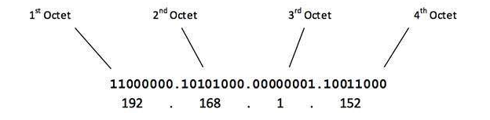
The number of networks and the number of hosts per class can be derived by this formula –
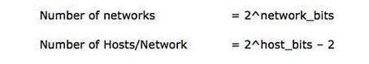

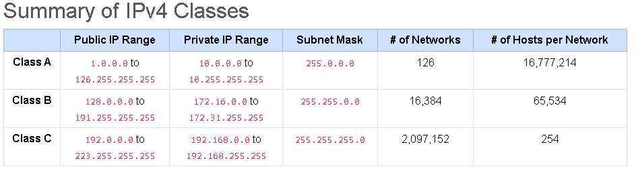
- Classless Addressing
IPv4: The "Old School" Phone NumberIPv4 was the first major version of IP.1 It uses a 32-bit address, which looks like four numbers separated by dots (e.g., 192.168.1.1).Because it's 32-bit, the total number of possible addresses is:2^32 \approx 4,294,967,296 \4.3 billion might sound like a lot, but in a world with billions of smartphones, laptops, and smart fridges, we’ve actually run out!
Classless Addressing (CIDR)
To stop wasting addresses, we invented CIDR (Classless Inter-Domain Routing) in 1993. Instead of rigid classes, we use a "slash" notation to say exactly how many bits belong to the network.
Example: 192.168.1.0/24
The /24 means the first 24 bits are the "zip code" (network), and the remaining bits are for the "house numbers" (hosts).
This flexibility allowed us to chop up networks into exactly the size needed.
What is CIDR?
In the old system, you were stuck with blocks of 256, 65,536, or 16 million. CIDR says, "Let’s stop looking at classes and start looking at individual bits."
We use a slash (/) followed by a number to indicate exactly how many bits are reserved for the Network ID.
CIDR | Subnet Mask | Total IPs | Usable IPs | Common Use
/30 | 255.255.255.252 | 4 | 2 | Point-to-point (Router to Router)
/29 | 255.255.255.248 | 8 | 6 | Small office with a few servers
/24 | 255.255.255.0 | 256 | 254 | Standard Home/Office LAN
/20 | 255.240.0.0 | 4,096 | 4,094 | Large University or Enterprise

VLSM( Variable Length Subnet Masking) Allows you to cut one giant slice for the server room, medium slices for the marketing team, and tiny "sliver" slices for the printers.
Example: Imagine you have one block of addresses (192.168.1.0/24).
- Sales Dept (100 people): Give them a /25 (128 addresses).
- HR Dept (50 people): Give them a /26 (64 addresses).
- IT Dept (20 people): Give them a /27 (32 addresses).

